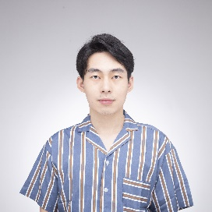
z

Jinda Li Graphics Programmer

jinda.li@outlook.com
https://neiljnda.github.io/
https://www.linkedin.com/in/jinda-li/





PROJECT EXPERIENCE

A Cloud’s Adventure
Ongoing game project, based on my master’s thesis project at Aalto University
- Simulated an interactive cloud with mixed graphics tech in Unreal Engine, including particle simulation, position-based dynamics and custom shading.
- Designing core game mechanics, small-scale open world and exploration experiences.

Computer Graphics Samples
Check images and details Here
- Extended Nvidia Framework to realize Global Illumination. The radiosity method is adopted and the Quasi Monte Carlo Sampling with Halton sequence is implemented.
- Raytracing Ambient Occlusion is implemented together with Bounding Volume Hierarchy and Surface Area Heuristic.


WORK EXPERIENCE


Unity Developer Feb. 2024 - Mar. 2025
Mixed Reality, Microsoft
Research projects to deliver state-of-the-art products
Cross-platform VR Tools: Developed Unity-based AR-in-VR simulator for research, integrating holographic rendering, eye-tracking, night vision, etc.
HoloLens2 Applications: Engineered AR applications with gesture-based interactions.

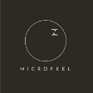
AI Game Developer Sep. 2023 - Apr. 2024
AI-Driven Open World Engine, Microfeel
Start-up company focusing on Generative AI and UGC in Games
Implemented AI procedural building generation using LLMs in Unreal.
Pioneered 3D Gaussian Splatting rendering in Unity for real-time photorealistic scene reconstruction.


SKILLS
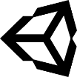 |  |  | 
Unity | Unreal | C++/C# | Shader
 |  |  | 

 |  |  | 
VR/AR | Python | Git | JavaScript
 |  |  | 
 |  |  | 
React | Parallel Programming | Blender | Linux
 |  |  | 


EDUCATION
Electrical Engineering, Southeast University (China)
Bachelor of Engineering 2016-2020

Game Design and Production, Aalto University
Master of Science 2021- 2025

